Clerk – Mrs Carol Barker, 5 High Street, Hinderwell, Saltburn, Cleveland, TS13 5JX
Tel Office: 01947 841382 e-mail: hinderwellparish@tiscali.co.uk

TO: MEMBERS OF THE COUNCIL
You are hereby required to attend the meeting of Hinderwell Parish Council at St Hilda’s Old School, Hinderwell on Thursday 3rd September 2020 at 7.00pm for the purpose of transacting the following business.
Public Notice of the meeting has been given in accordance with Schedule 12, Paragraph 10 (2) of the Local Government Act 1972
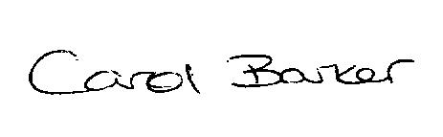
………………………….…………………………………...Carol Barker, Clerk to the Council

AGENDA

- To receive apologies for absence and approve reasons for absence

- To receive Declarations of Interest in respect of any of the following Agenda items

- Minutes of previous meetings in March and August 2020.

- Matters arising from previous minutes

- North Yorkshire Police Report

- Reports from Borough/County Councillors

- Planning Matters: to consider applications: NYM/2020/0560/FL, 0573/FL, 0597/LB, 0604/FL

- Finance: Authorisation of cheques Interim Audit - appoint scrutineers.

- Barrass Sub Committee

- Play Areas, Hinderwell and Staithes

- Remembrance Day Service : 8th November 2020

- Correspondence

- Parish Maintenance

- To notify the Clerk of matters for inclusion on the Agenda for the next meeting

Date of Next Meeting: Thursday 1st October 2020 7pm, St Hilda’s Old School, Hinderwell.

